Before the experiment officially begins, mark the origin of the camera and the movement position. The red coordinate axis in Figure 1 represents the origin position of the experiment.

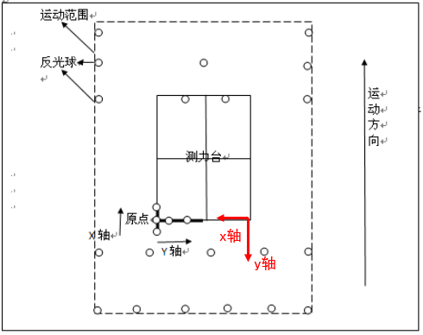
Fig 1 Schematic diagram of the experimental site

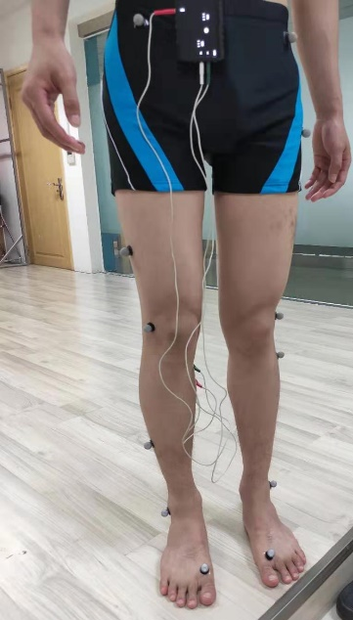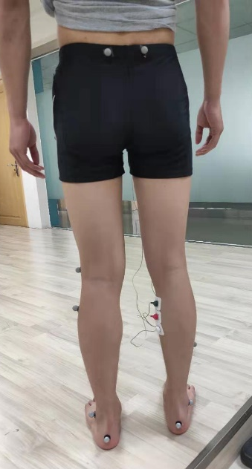
参考
通道2

通道1
LPSI
RPSI
LTHI
LTIB
RTOE
RANK
RKNEE
RTIB
RTHI
RASI

Fig 2 Human body reflective ball marking information

